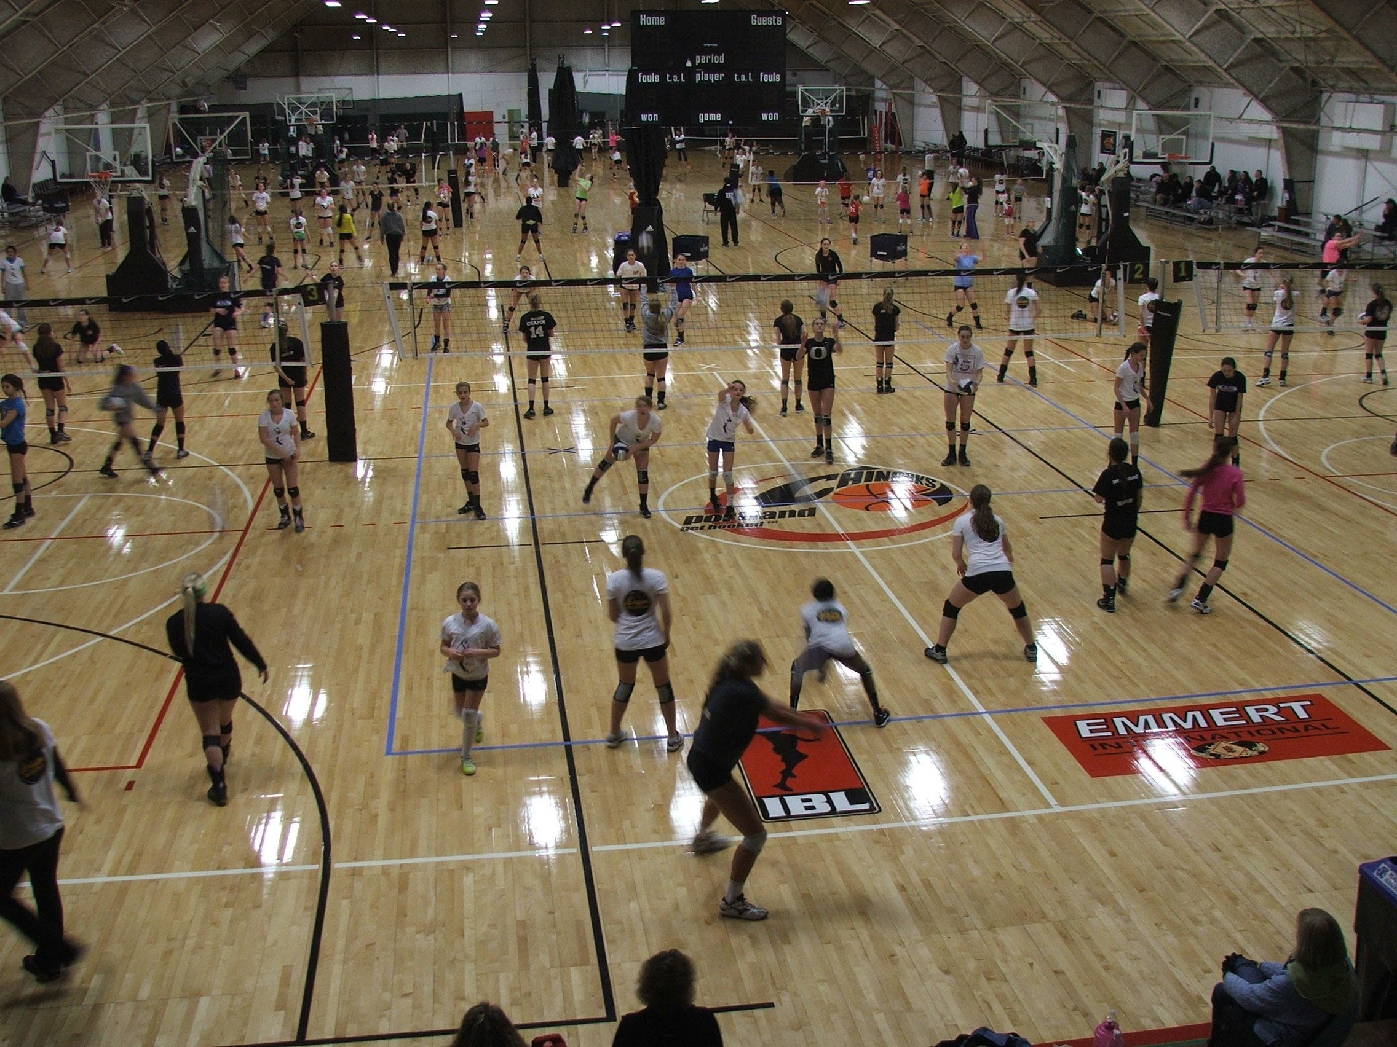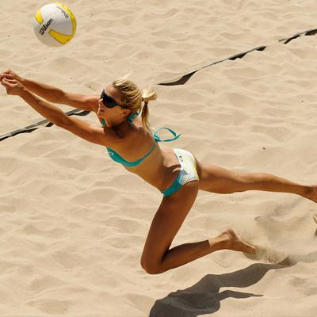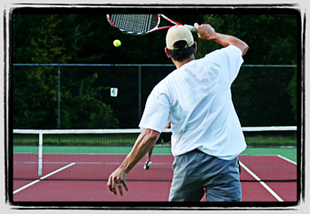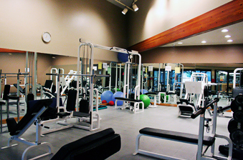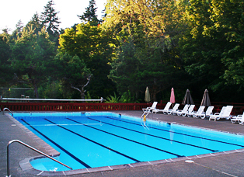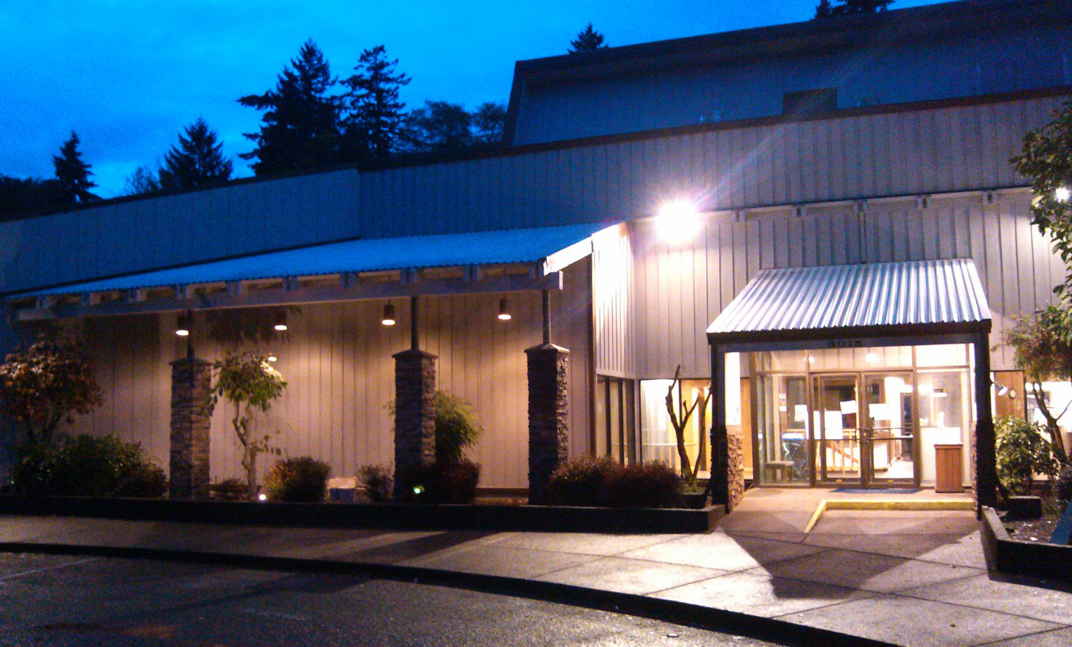

* Sand Volleyball Kid’s Camps
* Swimming Fitness Tennis
* **Summer Membership**
* **Information**

**3015 SE Berkeley Place, Portland, OR 97202**

**Phone: 503-653-0820 Email: eastmorelandcourts@gmail.com**

**Eastmoreland**

**Courts and Racquet Club**

**Facebook.com/EastmorelandCourts**

* Outside groups, such as birthday parties and sport camps, may join Open Swim at times. Advanced notice will be posted.
* The pool may close on days of inclement weather. Notification will be made on our Facebook page or via email.

### **Anticipated Summer Pool Schedule**

|  |  |  |  |  |  |  |
| --- | --- | --- | --- | --- | --- | --- |
| **Mon.** | **Tue.** | **Wed.** | **Thu.** | **Fri.** | **Sat.** | **Sun.** |
|  |  |  |  |  |  |  |
| 8:00 am  until  1:00 pm  Swim Lessons & Rentals |  | 8:00 am  until  1:00 pm  Swim Lessons & Rentals |  | 8:00 am  until  1:00 pm  Swim Lessons & Rentals |  |  |
| 11:00 am  until  1:00 pm  Rentals | 11:00 am  until  1:00 pm  Rentals | 11:00 am  until  1:00 pm  Rentals | 11:00 am  until  1:00 pm  Rentals |
| 1:00 pm  until  8:00 pm  OPEN SWIM | 1:00 pm  until  8:00 pm  OPEN SWIM | 1:00 pm  until  8:00 pm  OPEN SWIM | 1:00 pm  until  8:00 pm  OPEN SWIM | 1:00 pm  until  8:00 pm  OPEN SWIM | 1:00 pm  until  8:00 pm  OPEN SWIM | 1:00 pm  until  8:00 pm  OPEN SWIM |

**OUTDOOR COURT PUNCH CARDS**

These are valid for tennis courts and sand volleyball courts. They may be purchased for $150 for 10 plays or $270 for 20 plays. The 10-play card may only be used by the person who purchased it. The 20-play card may be shared with a spouse or family member. (Max of 2 people per card)

**SAND COURT RENTALS**

Sand volleyball courts can be rented for $35.00/court hour. Advance reservations required.

**POOL DECK RENTALS**

Portions of the upper wood pool deck can be rented for a cost of $10/table per hour.

**SUMMER MEMBERSHIP POLICIES**

Summer memberships are a flat fee and will not be pro-rated. Summer members will not be allowed to charge purchases to a club account. All summer members much check in at the front desk upon arrival. Towels are not provided for use of the pool. Please bring your own. No pets allowed on club premises unless it is a legal guide animal with permit.

**FOOD & BEVERAGE POLICY**

Outside food and beverages of any kind are not permitted inside the facility or outdoor courts. The exception is reusable, screw top water bottles. Food and non-alcoholic beverages are permitted on all outside wooden decks. Food and beverages are not permitted within the fenced, cement pool deck. Alcoholic beverages are only permitted in the lobby and the upper pool deck. Any alcohol brought into the club from the outside will be confiscated.

**YOUTH POLICY**

All children age 14 or younger must be supervised at all times by a parent or guardian unless he/she is enrolled in a supervised class or camp. Immediate pick-up after class/camp is required. If your child is left after camp or class, you will be charged $20 for the first 15 minutes and $10 every 15 minutes after that. Youth must wear wristbands to swim. All children not potty trained must wear swim pants with snug elastic legs. Accidents may force the pool to close for several hours.

**SUMMER ACTIVITIES**

All summer activities with a fee must be paid at the time of registration. Refunds will not be given for activities requiring registration.

* A $50 enrollment fee is added at the time of registration.

** A Family membership includes 4 individuals residing at the same address. Additional family members or caregivers may be added for a charge of $35 per 30-day period.

**EXECUTIVE MEMBERSHIPS INCLUDE:**

Indoor basketball courts when available, outdoor tennis courts, resistance training, cardio equipment, outdoor pool, locker rooms, and sauna.

**POOL ONLY PUNCH CARD**

A Pool Membership Punch Card is just for the use of the pool. It is $90 for 10 visits. Any visit to the pool, or pool deck, will result in one punch deducted.

**POOL ONLY GUEST PASS**

Single day pool guest pass is $10 and an active member must accompany the guest.

|  |  |  |  |  |
| --- | --- | --- | --- | --- |
| **MEMBERSHIP TYPE** | **30 day** | **60 day** | **90 day** | **120 day** |
| Family Executive | $275 | $480 | $595 | $690 |
| Individual Executive | $220 | $360 | $460 | $535 |
| Outdoor Court Individual | $60 | $112 | $155 | $190 |
| Outdoor Court Couple | $99 | $185 | $260 | $315 |
| Pool Only Family | $199 | $325 | $445 | $540 |
| Pool Only Individual | $129 | $230 | $340 | $380 |

### **Membership Plans**

**Eastmoreland Courts and Racquet Club**

**3015 SE Berkeley Place, Portland, OR 97202**

**Phone: 503-653-0820 Email: eastmorelandcourts@gmail.com**

# **Summer Membership Rates and Policies**

**ALL-FACILITY DAY PASS**

A full one-day membership, which grants you the same access as an Executive Membership, is available for $15 per visit.

*Previously paid guest fees or punch cards may not be applied toward the purchase of a membership.*